## Virtual Collaboration Workshop for Working Groups

## Module 2: Tools and practices for collaborative, reproducible data science

**Date**: Wed, May 26, 2021; Cohort B

**Time**: 6:00pm- 8:00pm (Pacific Standard Time UTC -8)

**Zoom**: <https://ucsb.zoom.us/j/83107012379> [How to [Set up Zoom](https://support.zoom.us/hc/en-us/articles/201362033-Getting-Started-on-Windows-and-Mac)][recording]

**Host**: Julien Brun [brun@nceas.ucsb.edu](mailto:brun@nceas.ucsb.edu)

Carrie Kappel [kappel@nceas.ucsb.edu](mailto:kappel@nceas.ucsb.edu)

**Workshop goal:** Today we will be exchanging on “good enough” practices to:

* Create a shared virtual environment
* Develop reproducible workflows for your analysis
* Manage your data

**Quick introduction:**

* Welcome, thank you for joining us again!
* We’ll be using Zoom for video calls & Google docs for notes
  + Everything you share in this doc is available to everyone else on the call
  + If you have resources to share, we welcome them!
* We will have a 5-min break from 7:00-7:05

### Workshop Tips

* **Code of Conduct** ([full version](https://live-ncea-ucsb-edu-v01.pantheonsite.io/sites/default/files/2020-02/NCEAS_Code-of-Conduct_2019.pdf)) (1 min)
  + Be respectful, honest, inclusive, accommodating, appreciative, and open to learning from everyone else.
  + Do not attack, demean, disrupt, harass, or threaten others or encourage such behavior.
  + Reporting: Please report any issues to:
    - Courtney Scarborough, NCEAS Deputy Director [scarborough@nceas.ucsb.edu](mailto:scarborough@nceas.ucsb.edu)
* **Workshop Structure** (4 min)
  + Discussion-based and requires active engagement
    - Mix of activities, short slide decks, google-docing, breakout rooms
    - Zoom & Google Docs: side-by-side so you can see both (no screen sharing today)
  + Zoom to connect us remotely
    - Videos on when possible (“faces on”) – but okay if not for any reason
      * Zoom Gallery View: button at top right
        + *Also: Settings > Video > Display up to 49 participants*
    - Mute liberally & quickly to limit background noise
  + Other ways to engage:
    - Zoom Chat – Carrie will monitor (also monitoring the waiting room)
    - Zoom’s nonverbal participation icons > click on the toolbar at the bottom of the main window   
      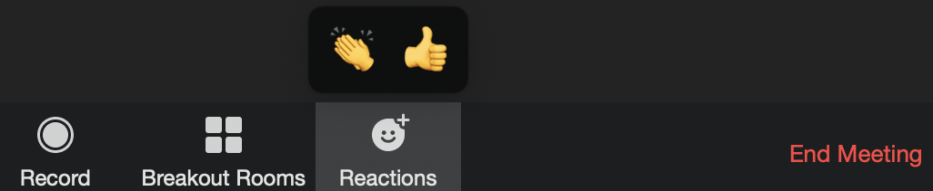
  + Name the power dynamics and emphasize that everyone is welcome here and has value to contribute
  + We all have different skills and backgrounds, let us leverage all this knowledge!

### 

**⚡️Record the meeting! ⚡️**

### Welcome! [6:02 - 6:07] – Julien

* **Hello!**
  + Welcome back for our second workshop!
  + We are recording the meeting to be shared with your Working Group (WG) collaborators
* **Today’s goals** (2 min)
  + Create a positive learning space where everyone is welcome and feels comfortable participating
  + Exchange on good enough practices to help you to:
    - Create a collaborative workspace
    - Manage your data in an efficient way
    - Develop reproducible workflows for your analyses
  + Develop a mindset to build from these recommendations, there is no one size fits all in data science
  + Develop a shared resource from this workshop as a reference for your WGs
  + Keep building our SNAPP community within your working group and across WGs

### Results chain Mixer [6:07 - 6:27] – Carrie

* **Homework Mixer** (20 mins)
  + Discussion:
    - What big picture goals are you driving toward?
    - What audience(s) are critical to your success?
    - What do you want them to do or do differently as a result of your work?
    - What activities will you pursue to create the conditions that will enable the intermediate and long term outcomes you are driving toward?
  + 2-3 mins feedback from a team perspective
  + What struck you about that conversation? What new insights emerged?

### 

### Virtual collaborative environment [6:27-6:40] – Julien

* **Building your collaborative space** (9min)
  + **Goal**: creating a ***space for you to collaborate*** and ***centralize the information*** of your project   
    *=> you are coming from different institutions, therefore most likely using different tools that others might not have access to!!!*

*=> make it easy for you and others to find everything in one place quickly*

* + **Overarching questions for your working group**
    - Can everybody have access to this tool? This should overrule the “best” tool *=> adoption*
    - What team standards should you set on how to use these tools? Example: sharing a new document -- prefer adding document to the shared drive and send the link rather sending it as an attachment
    - Allow flexibility
* **This virtual environment needs to cover**:
  + *Zoom poll: Select 3 collaborative tools you anticipate needing the most*
  + *Discussion: Which tool you are thinking of using for:*
    - **Document sharing**   
      Google Drive,
    - **Communication**Email,
    - **Data Management**
    - **Collaborative coding and sharing**
    - **Project Management**
    - **Product sharing**   
      Spreadsheets, webpages, interactive data visualization  
       *Rmarkdown websites and Shiny applications*E.g.: LTER Soil Organic Matter website: <https://lter.github.io/som-website/index.html>  
      (NCEAS’ [tutorial](https://nceas.github.io/training-rmarkdown-website/tutorial.html) to create Rmarkdown websites)

### Data Management [6:40 - 7:00]

Synthesis research is data intensive by nature. We thus strongly encourage your group to plan your data management as well as discuss who is going to lead and be involved in this task. A lot of working groups underestimate the time data collection and harmonization will take.

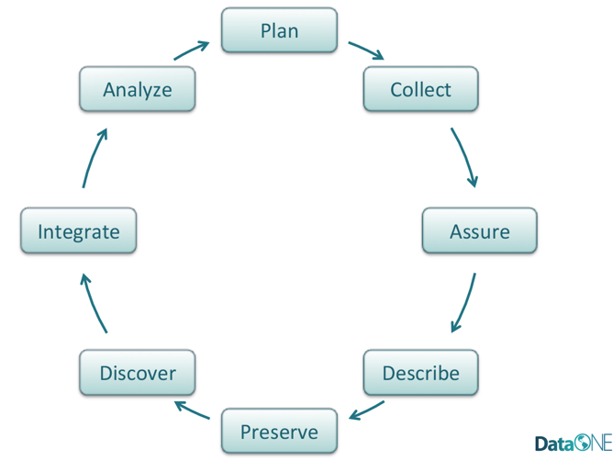

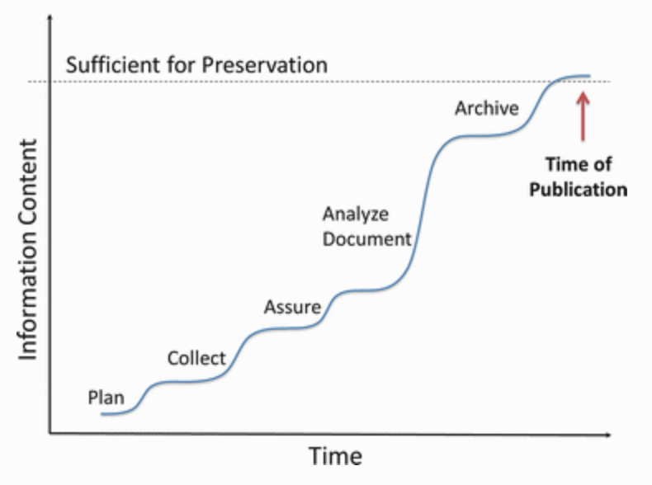

*Credits: DataONE* [*data management*](https://www.dataone.org/sites/all/documents/DataONE_BP_Primer_020212.pdf)*; Friedrich Recknagel and William K. Michener. “Ecological Informatics”, 2017)*

* **Discussion** (12 mins)
  + Our asks:
    - Go around the room and share your ideas from the prompts.
    - Listen to each other; avoid judgment and solutioneering.
  + Prompts:
    - How much data will be collected and how will it be organized?
    - Are there any legal constraints associated with acquiring, using and sharing project data?
    - How much time will be needed to manage and harmonize the data; who will be responsible for doing so?
    - How long should the data be preserved and where is the best location to do so?
* **Resources for Archiving SNAPP Products**Most of the SNAPP datasets have been archived in the KNB data repository (see below for alternatives). Here is some information about SNAPP archives and how to submit data to the KNB:
  + List of the [SNAPP products on KNB](https://knb.ecoinformatics.org/data/query=SNAPP) data repository
  + Archive example:
    - This SNAPP Amazon Waters product has been downloaded more than 4.5k times and has an associated data paper to further describe the product:
      * Data Archive:<https://doi.org/10.5063/F1BG2KX8>
      * Associated Data Paper:<https://doi.org/10.5194/essd-8-651-2016>
    - Feedback from PI: M. Goulding (PI of Amazon Waters) stated that *“on numerous occasions, people would ask us when the data would be available, and it was a pleasure to let them know that it already was available online. This placed our SNAPP team in the open-access arena, which is to say, the future.”*
  + Data submission information:<https://knb.ecoinformatics.org/about>
    - Note: add “SNAPP” as a keyword to your archive so we can list it!
* Potential repositories  
  If you would like to use another data repository, here is a list of some generic ones:
  + Data based products:
    - [NODC](https://www.nodc.noaa.gov/index.html)
    - [NCDC](http://www.ncdc.noaa.gov/customer-support/archiving-your-data-ncdc)
    - [Dryad](http://datadryad.org/)
  + Report / document driven products:
    - [Zenodo](https://zenodo.org/)
    - [Figshare](https://figshare.com/)

**Pause Recording!**

### BREAK (5 min) [7:00-7:05]

Please stay in this Zoom room (just mute & turn off camera) and rejoin at 7:05

***If you have not already created a GitHub username, please do so now:***

1. *GitHub:* [*https://github.com*](https://github.com)
2. *Follow optional* [*advice on choosing your username*](https://happygitwithr.com/github-acct.html)
3. *Remember your username, email and password; we will need them after break!*

**Start Recording!**

### Data Management II [7:05 - 7:15]

* **Data collection** (5 min)
  + We strongly encourage you to track the provenance of the data using a [data log](https://docs.google.com/spreadsheets/d/1LLpOyydCGTZdY8Xk2fDmTPVy8efF-47GtEXkAjvYsJI/edit?usp=sharing)
    - Source / owner (Person, institution, website, ….)
    - When was it acquired ?
    - By whom on the WG ?
    - Where is it currently located (Google drive, server, ….) ?
    - Short description of the data
    - Track if it is used in your analysis
* **Naming things** (5 min)
  + As for the tools, ***the most important is to make it consistent!***
  + Use a naming convention for files and folder
    - Avoid spaces (use underscores or dashes)
    - Avoid punctuation or special characters
    - Try to leverage alphabetical order (e.g. start with dates: 2020-05-08)
    - Use descriptive naming (metadata)
    - Use folders to structure/organize content
    - Keep it simple
  + Make it programmatically useful
    - Useful to select files (Wildcard *, regular expression)
    - But don’t forget Humans need to read file names too 😉
  + Which one is the most useful name?
    - 06-2020-08-light-sensor2-plot1.csv
    - 2020-05-08_light-sensor-1_plot-1.csv
    - Measurement 1.csv
    - 2020-05-08-light-sensor-1-plot-2.csv
    - 2020-05-08-windSensor1-plot3.csv

Good [reference](https://speakerdeck.com/jennybc/how-to-name-files) on this topic from Jenny Bryan (RStudio)

### Developing reproducible workflows [7:15-7:30]

Here we use the term “workflow” as a succession of steps that enables you to go from raw-data to the final product and how it is use to communicate:

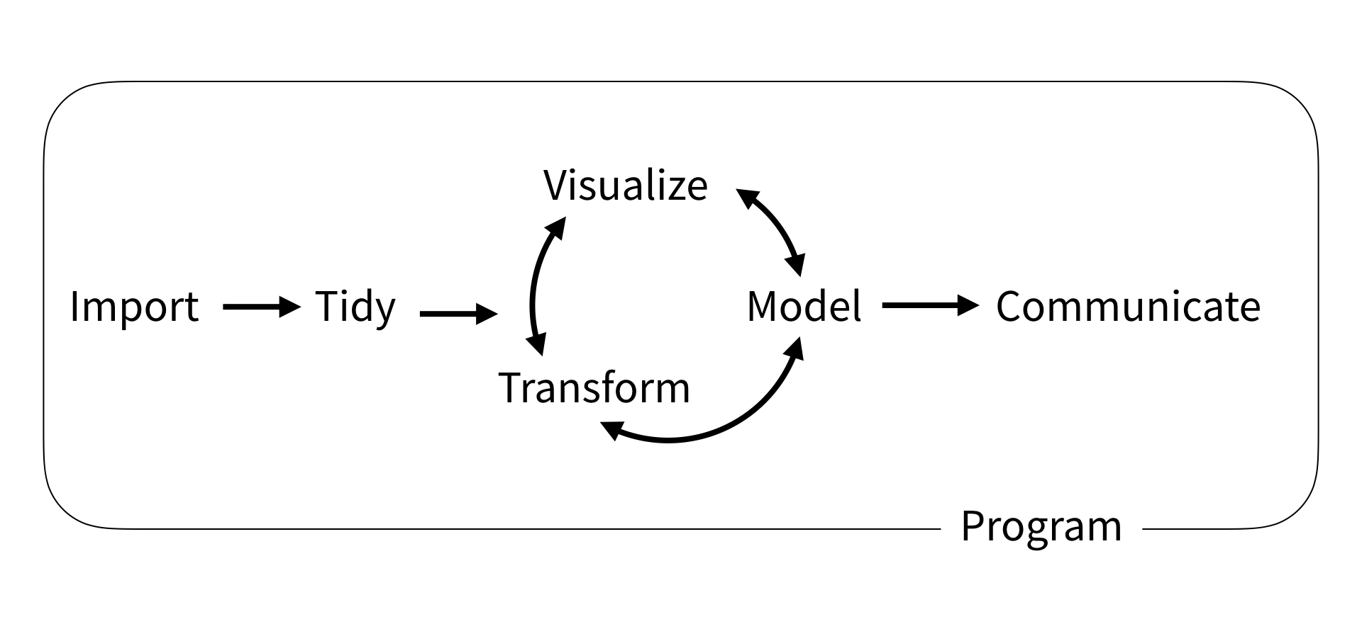

*From* [*https://rstudio-education.github.io/tidyverse-cookbook/how-to-use-this-book.html*](https://rstudio-education.github.io/tidyverse-cookbook/how-to-use-this-book.html)

Two points to stress about this figure:

* Workflows are not linear
* Programming box
* **Why should we develop workflows?** (5 min)
  + Iterate quickly
  + Integrate new information easily
  + Yep, you’ll need to program this
  + There are tools and practices to help us to build workflows combining data and scripts to collect, process, transform and analyze our data
  + Includes also visualization and sharing of your results!
  + Here is a workflow example from the *LTER Soil Organic Matter* working group:

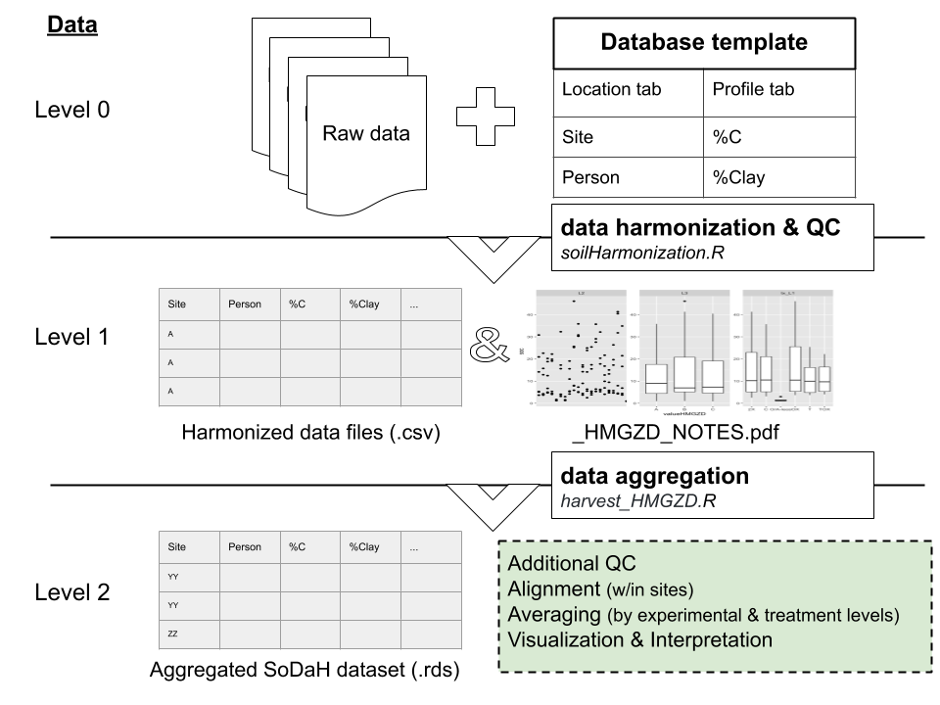

=> R package: [soilHarmonization](https://github.com/lter/soilHarmonization)

* **Why reproducible?** (5 min)
  + It is for you & your future you!!
    - Synthesis science is highly iterative
    - This is a 2-year project… among other things
  + It is for your collaboration
    - Others need to be able to use your work
    - Others will be able to contribute
* **How to develop a reproducible workflow?** (5 min)
  + Script, script, script… Did I say script?!?
  + Script everything / leave copy-pasting behind
    - Spreadsheets are good; but don’t over use them
    - How you structure your data matters
  + Document
    - Comment your code
    - Keep track of your data provenance (see above)
    - Write metadata to describe your products
      * Capture as you go in notebooks ([RMarkdown](https://rmarkdown.rstudio.com/), [Jupyter Notebook](https://jupyter.org/))
  + Use the available tools to keep things in sync == avoid duplication
    - Data
      * When possible find a common computing space (cloud)
        + Accessing the same data
        + Using the same path
        + Using the same version of software
      * Data repositories (e.g. [KNB](https://knb.ecoinformatics.org/), [EDI](https://portal.edirepository.org/nis/home.jsp), ...)
        + Version control for you data
    - Code
      * Version control: git
      * GitHub
  + Publishing is part of your analytical workflow 💯
    - Use notebooks (Rmarkdown, Jupyter notebook)
    - Publish and share analysis and results online (e.g. [GitHub pages](https://pages.github.com/), [netlify](https://www.netlify.com/), ...)
    - Leverage continuous integration
  + Workflows are rarely linear! (I think I already mentioned that 😎)
* **Collaborative coding and results sharing** (15min)
  + Version control (git) concepts:
    - Never use “save as” again

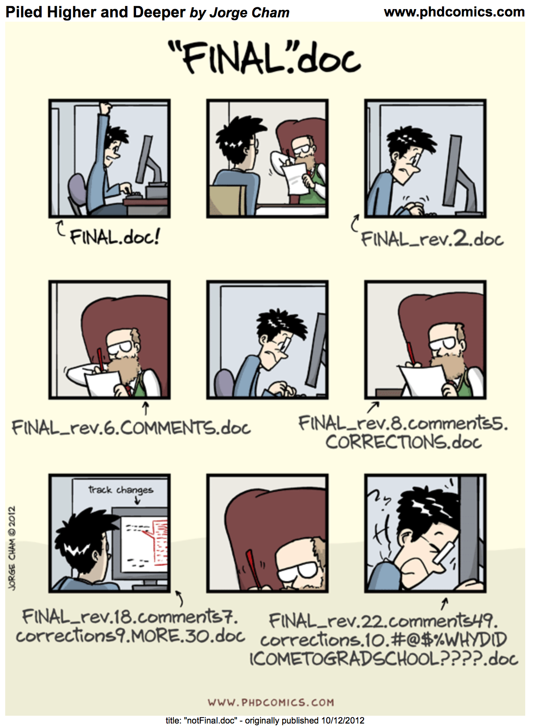

* + - Track files and their changes (like Google docs!!)
      * Named versions!
    - Know who changed what
    - What git (“software” that track changes) is good at:
      * Merging different versions into one
      * Helping with documenting changes
      * Revert back to older version
      * Managing small files, especially text/ascii files
        + Current limit: 100MB/file
    - What git is not good at:
      * Managing large files
      * It is not a backup replacement!!
    - The fancy git words:
      * *Repository or repo*: **folder** in which git is tracking file changes  
        *=> this helps you to encapsulate your work and make it portable*
      * *Commit*: Saving a specific version of a file
        + Like taking a snapshot
      * *Push*: send the latest changes on your computer to the cloud / remote repository, in our example GitHub.com
      * *Pull*: get the latest changes to your computer from the cloud / remote repository, in our example GitHub.com
      * *Conflict*: when you outsmarted git 😅 and need to help it to select the version you want to keep
  + Collaborative coding (GitHub)
    - The coding social platform for ~~nerds~~ ALL
    - Publish and share your work (see [here](https://openscapes.github.io/series/github-pub.html#editing-files-from-github.) for more)
    - Visualize your files and modifications (highlight changes in your code; can render files such as csv, png, …)
    - Manage projects and tasks ([GitHub issues](https://openscapes.github.io/series/github-issues.html))
    - Uses the [markdown](https://guides.github.com/features/mastering-markdown/) syntax everywhere (like Rmarkdown and Jupyter notebooks!)

### Hands-on GitHub.com [7:30 - 7:55]

*In this section we will be using the GitHub.com website and show you do not need to be a programmer to use it!*

* **Group exercise: GitHub** (20 min)
  + Our asks:
    - Help each other, everyone is bringing different skills! Talk it out!
    - Listen to each other; avoid judgment and solutioneering.
    - Have fun!
  + Prompt:
    - Create a repository:
      * Create a (first) repository following [these instructions steps 1-6](https://help.github.com/en/github/getting-started-with-github/create-a-repo)

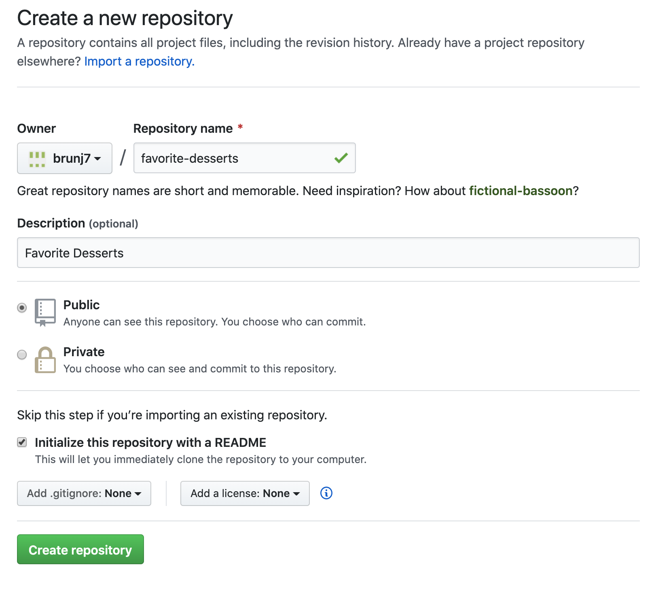

* + - Modify the README file   
      (can be done at the same time as Person 3 below):
      * Check your email to accept the invitation
      * Go to the repository website (link is provided in the invitation)
      * Click on pen at the top of the README.md file



* + - * Replace the title (first line starting with #) with something better! Maybe Favorite Desserts
      * Add your name and your favorite dessert below the title:   
        *- Julien: crepes*
      * Add a descriptive message   
        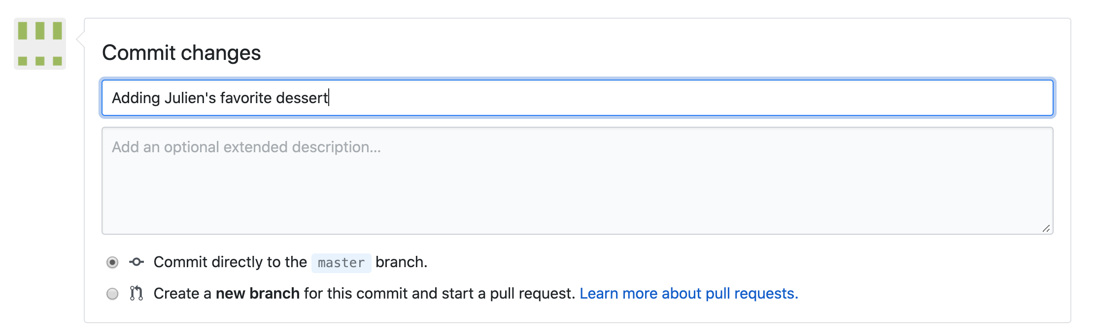
      * Save (“Commit”) your changes  
        
    - Add a file   
      (can be at the same time as above!!):
      * Download this [csv file](https://aurora.nceas.ucsb.edu/~brun/favorite_desserts.csv) file about your favorite desserts to your computer
      * Upload it to your favorite desserts repository
        + just drag and drop!
        + Add a short message about the file  
          E.g. “Adding dessert csv”
        + Click on the filename to see it!
      * You should have something similar to this repo: <https://github.com/brunj7/favorite-desserts>
    - Bonus:
      * Try to edit the csv file directly on GitHub!
      * Invite collaborators to repository ([here is how](https://help.github.com/en/github/setting-up-and-managing-your-github-user-account/inviting-collaborators-to-a-personal-repository))
* **Whole-group share-out** (5 mins) – All 11:40
  + *Add the link to your repo as well, if you’d like to!*
  + <https://github.com/brunj7/favorite-desserts>

***=> No need to be a programmer to contribute to analytical workflows with GitHub!!***

### Closing [7:55- 8:00]

* **Summary of today’s goals: please continue and pass-forward these practices**
  + Beginning of a collaboration
  + Discuss how NCEAS support team can help you during your WG project
  + Exchange on good enough practices to help you to develop strategies to:
    - Manage your data in an efficient way
    - Develop reproducible workflows for your analysis
  + Develop a mindset to build from these recommendations, there is no one size fits all in data science
  + Develop a shared resource from this workshop as a reference for your WGs
  + Keep building community within your working group and across WGs
* **Shout-outs & thanks**
* **Pluses (what did you like about these trainings that we should continue?)**
* **Deltas (what suggestions do you have for improvement for either session?)**

* **Additional resources**
  + Collaboration:
    - Collaboration and Productivity in Scientific Synthesis: <https://doi.org/10.1525/bio.2011.61.11.9>
    - Gender-Heterogeneous Working Groups Produce Higher Quality Science: <https://doi.org/10.1371/journal.pone.0079147>
    - Best Practices for Virtual Participation in Meetings: Experiences from Synthesis Centers: <https://doi.org/10.1002/bes2.1290>
    - Ten Simple Rules to Enable Multi-site Collaborations through Data Sharing: <https://doi.org/10.1371/journal.pcbi.1005278>
  + Data and scientific workflow management:
    - Some Simple Guidelines for Effective Data Management:  
      <https://doi.org/10.1890/0012-9623-90.2.205>
    - Basic concepts of data management: <https://www.dataone.org/education-modules>
    - Good enough practices in Scientific Computing:  
      <https://doi.org/10.1371/journal.pcbi.1005510>
    - Script your analysis: <http://www.nature.com/nature/journal/v541/n7638/full/nj7638-563a.html>

* + Open Science:
    - The Tao of open science for ecology:   
      <https://doi.org/10.1890/ES14-00402.1>
    - Challenges and Opportunities of Open Data in Ecology:   
      <https://doi.org/10.1126/science.1197962>
    - Scientific computing: Code alert  
      <https://doi.org/10.1038/nj7638-563a>
    - Our path to better science in less time using open data science tools  
      <https://doi.org/10.1038%2Fs41559-017-0160>
    - FAIR data guiding principles  
      <https://doi.org/10.1038/sdata.2016.18>
    - Skills and Knowledge for Data-Intensive Environmental Research <https://doi.org/10.1093/biosci/bix025>
    - Let go your data  
      <https://doi.org/10.1038/s41563-019-0539-5>